
High Level Solution Design
Project Name
Author Name & Title

CONTENTS
1. Document Control 3
1.1 Revision History 3
1.2 Reference / Related Documents 3
1.3 Review and Approval 4
2. Project Summary 5
2.1 Project Background and Overview 5
2.2 Business Benefits 5
3. Solution Scope 6
3.1 Summary of business functional requirements 6
3.2 Summary of Non-functional requirements 6
3.3 Application Tier 6
4. Architecture Design Decisions 7
5. Assumptions, Issues & Dependencies 8
5.1 Assumptions 8
5.2 Issues and concerns 8
5.3 Risks 8
5.4 Dependencies 8
6. Compliance 9
6.1 IT Architecture Principles Alignment 9
7. Application Architecture 11
7.1 High Level Overview 11
7.2 Components & Functions 13
7.3 Integration 13
7.4 Impacted Systems 14
8. Data Architecture 15
8.1 High Level Data Architecture Overview 15
8.2 Data Model \ Data Flow Diagrams 15
9. Infrastructure 16
9.1 High Level Infrastructure Architecture Overview 16
9.2 Infrastructure 16
9.3 Database 16
9.4 Network Services 17
9.4.1 Network Cabling 17
9.4.2 Data Centre or Edge Switching 17
9.5 Firewall Policy Overview 17
9.6 Internet Access 17
9.7 DNS Configuration 17
9.8 Software Components 17
9.9 Infrastructure Uptime & Availability 17
10. Cyber Resilience 18
10.1 Security Overview 18
10.2 Data Governance and Classification 18
10.3 Cryptographic Keys & Certificate Protection 18
10.4 Application & Data Security 18
10.5 Identity & Access Management 19
11. Supportability & Monitoring 20
11.1 Monitoring Overview 20
11.2 Application Monitoring and Alerting 20
11.3 Infrastructure Monitoring and Alerting 21
11.4 Cyber Monitoring, Vulnerability Scanning and Alerting 21
11.5 Backup & Recovery 21
11.6 Updates & Patching 22
11.7 Maintenance Windows 22
11.8 Remote Access 22
11.9 Disaster Recovery 22
11.10 Capacity & Performance (Volumetrics) 22
11.11 Scalability 22
Appendix A: Terms & Abbreviations 23
Appendix B: Implementation Considerations 24

- Document Control
  - Revision History
Change as needed for your project.
Version | Issue Date | Description of Version / Changes | Author
0.0.1

  - Reference / Related Documents
Include related project documentation, internal or externally provided. Add rows as required.
Title | Version | File Name & Location
Corporate Risk Framework | Aug 2020 | Risk Management Framework.pdf
Enterprise Architecture Principles | 1.1 | Enterprise Architecture Principles 1.1
Application Tier Assessment Model |  | Application Tiering
Privacy Impact Assessment |  | Group Manager Privacy & Information Governance
Cyber Questionnaire
Business Requirements Document (BRD)
Related Patterns
Vendor documentation

  - Review and Approval
Name | Title, Area | Action  (Info, Review  or Approval) | Sections
Greg Hobson | Group Manager Architecture & Engineering | Info
Christian Saboisky | Architecture Practice Manager | Info
Nabil Kassis | Enterprise Architect | Review / Approve
Casey Moon Watton | Enterprise Architect | Review / Approve
Michael Mieczkowski | Enterprise Architect | Review / Approve
Maurijn Donders | Enterprise Architect | Review / Approve
Norman Tovine | Enterprise Architect | Review / Approve
Francois Botes | Enterprise Architect | Review / Approve
Robert De Stefano | Enterprise Architect | Review / Approve
Michael Martin | Solution Architect | Review / Approve
Rob Lawrance | Solution Architect | Review / Approve
Harmeet Sian | Solution Architect | Review / Approve
Noot Fang | Solution Architect | Review / Approve
Shoaib Alam | Integration Architect | Review / Approve
Anish Shrestha | Data Architect | Review / Approve
The Solution Architect is considered the author of this document with minimum sign off parties nominated above. The Enterprise Architect will assist on confirming relevant approvers.
After internal reviews are complete the Architecture Design Authority (ADA) process will confirm approval baseline status.

Note, reviewers may be required for accuracy of content and may not necessarily have approval authority.

- Project Summary
This section provides information about the project and associated projects or program.
  - Project Background and Overview
This project belongs to the program name.
The business owner/sponsor owner / sponsor.
The IT General Manager owner/sponsor owner / sponsor.

This project/program was initiated because describe the problem that this program/project is to remedy or improve.
It will provide describe the key benefits this project will give the business and its priorities. If applicable provide a statement about the larger program's objectives/intent which gives context to this document.
  - Business Benefits
The key business objectives and requirements to be addressed by this project, and the testing objectives that cover them, are detailed in the table below.

- Solution Scope
This section lists those requirements to be considered in relation to selection of the packages, along with those that have changed or have become excluded.
  - Summary of business functional requirements
Overview of the key functional requirements that effect architecture design decisions and direction applicable to this solution are:
Unique # | Category | Key Requirement
FR-01
FR-02
FR-03
  - Summary of Non-functional requirements
Overview of the non-functional requirements that effect architecture design decisions and direction applicable to this solution are:
Unique # | Category | Requirement
NFR-01 | High Availability | Define the acceptable RPO and RTO times for the application. Note that TSEG virtual infrastructure provides automated hardware failure recovery times of around 30ms
NFR-02 | Disaster Recovery | Include specific DR requirements for the application, where the default DR requirements provided by TSEG virtual infrastructure of 1- 4 hours is not suitable
NFR-03 | Performance | Include any specific performance objectives to be met, i.e.: maximum disk IOP requirements, User response times avg and 95th percentile etc

  - Application Tier

Existing Overall | Revised Overall
Tier 1,2,3 | Tier 1,2,3
Note the Platform Delivery Manager (PDM) is the owner of the tier assessment. The Solution Architect will document results. Link to the assessment process and file is located within the referenced documents section.

- Architecture Design Decisions

Decision ID
Decision To-Be Made
Options Considered
Preferred Option
Rationale
Decision
Approved By
Reference

Decision ID
Decision To-Be Made
Options Considered
Preferred Option
Rationale
Decision
Approved By
Reference

- Assumptions, Issues & Dependencies
  - Assumptions
The architecture assumptions made in deciding upon this selection are. Note unresolved issues will be included in the project issues and risks register.

Ref # | Assumption | Impact (if not true)
AS-01
AS-02
AS-03
  - Issues and concerns
An issue is a situation, action, problem, or question that demands action to resolve it. Left unresolved, an issue would impede or prohibit project-related progress or development by delaying or suspending work effort.
The architecture issues brought up in architecture and security reviews, as well as those related to unusual requirements, such as infrastructure, unique monitoring, or support, are:
Ref # | Issues Description | Assigned To | Target Resolution Date
IS-01
IS-02
IS-03
  - Risks
A risk is an uncertainty, liability, vulnerability, or opportunity that may cause the project to deviate unacceptably from the defined plan. Mitigation of a risk is within the control of the project.
The architecture risks associated with this solution are:
Ref # | Risk Description | Severity | Probability | Mitigation
RK-01
RK-02
RK-03

  - Dependencies
A dependency is a reliance on some aspect of a system that is external to the solution under discussion, over which the project may have little control.
The dependencies associated with this solution are:
Ref # | Description
D-01
D-02
D-03

- Compliance
  - IT Architecture Principles Alignment
IT Objectives
Compliance | ID | IT Objectives | Statement
Yes  No  N/A  TBC | EA-01 | Leverage IT assets | Leverage in the context of The Star IT, is the ability to maximise return from IT assets such as data, applications & integration, infrastructure, and network.
 | EA-02 | Enable new business capability | This objective involves IT providing an ability to utilise new technology to produce innovative new products and an ability to use existing technology in new and novel ways.
 | EA-03 | Reduce IT risk | Inherent in reducing IT risk is the ability to minimise exposure to untried or unproven infrastructure, system software and applications or unproven combinations of these components.
 | EA-04 | Minimise IT costs | Reducing IT costs requires efficiency improvements that reduce costs in application and infrastructure operations and maintenance.
 | EA-05 | Increase IT flexibility | Flexibility involves the ability to rapidly establish new products and business processes using existing IT systems. This enhances the competitiveness of The Star and its ability to respond to market conditions rapidly.
 | EA-06 | Improve speed to market | Speed to market from an IT context means an ability to apply changes to existing applications or deploy new applications in a timeframe that is congruent with business drivers.

IT Strategic Principles
Compliance | ID | IT Strategic Principles | Statement
Yes  No  N/A  TBC | EA-S1 | Think The Star Entertainment Group first | Solutions will consider the enterprise impact of architectural decisions.
 | EA-S2 | Abide by the agreed principles and governance framework | IT and Business units must agree the EA framework. EA objectives must be understood and agreed.
 | EA-S3 | Data is an enterprise asset | Data and information are shared resources across The Star and must be managed accordingly. The Star must recognise that data is not ‘owned’ by any one organisational unit, instead it is an asset that should be made available and shared across the enterprise.
 | EA-S4 | Reuse before buy or build | The approach to deployment of new IT applications, services and infrastructure is to reuse existing capability. If existing capability does not meet required capability, then a “buy” option should be considered before a “build” option.
 | EA-S5 | Secure by design | Security and compliance are embedded into business, application & integration, data, and technology architecture.
 | EA-S6 | Simple solutions | IT will be as simple as possible. Where complexity is required, it will be encapsulated and hidden behind an interface that is as simple as possible.

Data
Compliance | ID | Technical Principle Title
Y, N, N/A, TBC | EA-D1 | Manage data at an enterprise level
 | EA-D2 | Master data management
 | EA-D3 | Manage The Star data lifecycle
 | EA-D4 | Validate data at source
 | EA-D5 | Single source of truth
Application and Integration
Compliance | ID | Technical Principle Title
Y, N, N/A, TBC | EA-A1 | Architect, design and deploy The Star’s applications at an enterprise level
 | EA-A2 | Applications and integration will be modular in architecture and design
 | EA-A3 | Services must be exposed as APIs
 | EA-A4 | Control service access by policy
 | EA-A5 | Protect data integrity through privileged data services
 | EA-A6 | Think mobile when designing user-facing front-end software
 | EA-A7 | Think cloud when designing back-end application services
 | EA-A8 | Use separation of concerns to foster agility, efficiency, and resilience
 | EA-A9 | Use event processing
 | EA-A10 | Do Not Repeat Yourself (DRY)
Network, Infrastructure and Cloud
Compliance | ID | Technical Principle Title
Y, N, N/A, TBC | EA-NI1 | Avoidance of Proprietary Technologies and Standards
 | EA-NI2 | Consolidation and Rationalisation of Technology Services
 | EA-NI3 | Designed with Management Capabilities
 | EA-NI4 | Operationally Effective and Efficient
 | EA-NI5 | Designed within a converged Network
Cyber Security
Compliance | ID | Technical Principle Title
Y, N, N/A, TBC | EA-Sec1 | Minimise the attack surface
 | EA-Sec2 | Use defence in depth strategies
 | EA-Sec3 | Limit privileges to those specifically required
 | EA-Sec4 | Design for user accounts for each user
 | EA-Sec5 | Centralise Authentication, Authorisation and Accounting
 | EA-Sec6 | Protect data commensurate with its sensitivity and importance to the organisation
 | EA-Sec7 | Avoid outdated protocols and/or application versions

- Application Architecture
  - High Level Overview
Describe at a high level the chosen solution.
- It is mandatory to include a diagram of the impacted systems and how they interact with each other and users. Preferred layouts should include arrows indicating direction of data flows.
- The high-level overview should show the interactions between the primary system under discussion and other existing systems. The other systems are called involved systems and they may or may not require alteration to meet the business requirements.
- The diagram does not show all the direct interactions that may occur between the involved systems, only those relevant to this solution architecture
- Confirm if the solution aligns with 5-year roadmap.

Example 1
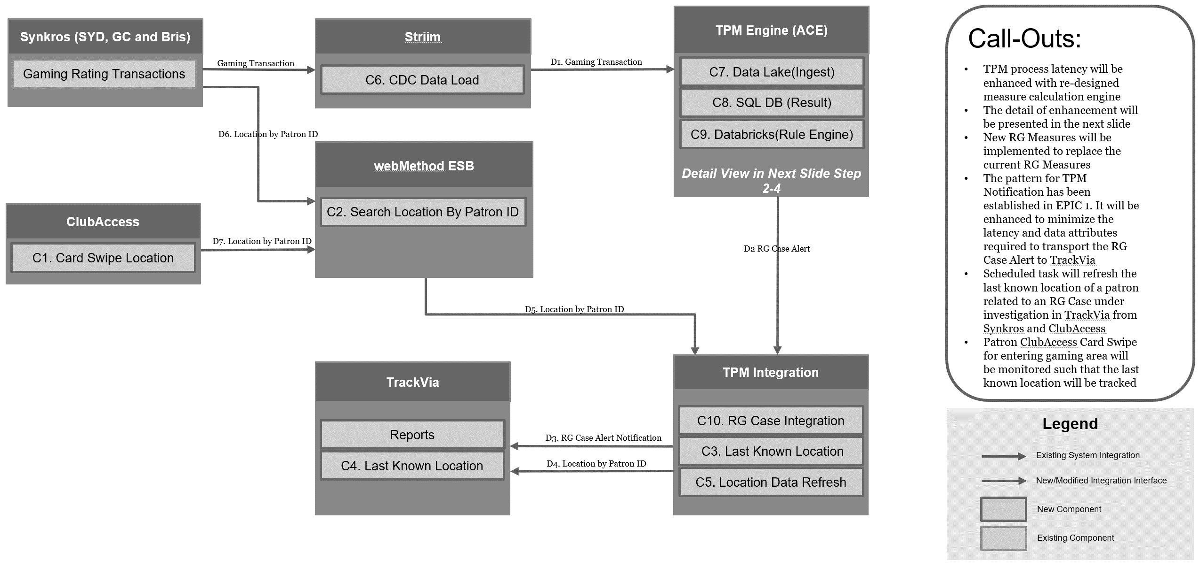

Example 2
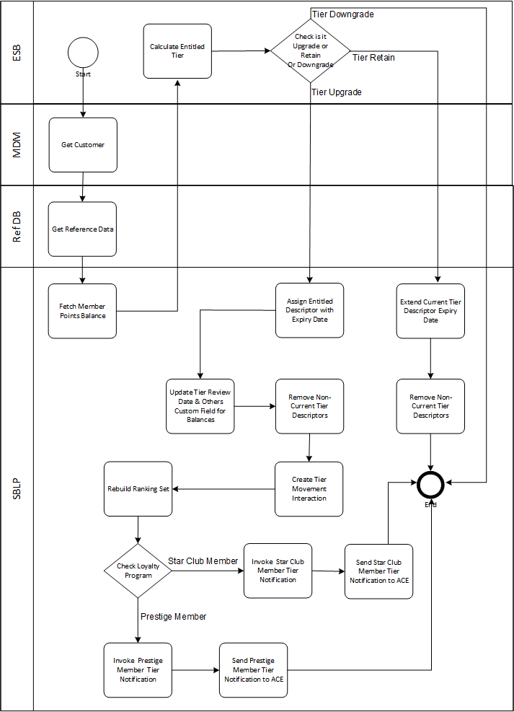

  - Components & Functions

Build Item # | R/R ID | Information exchanged | From APP | To APP | Interface Technique | Mechanism | Status | Frequency | Trigger | Security | Security Classification | Comment

Example
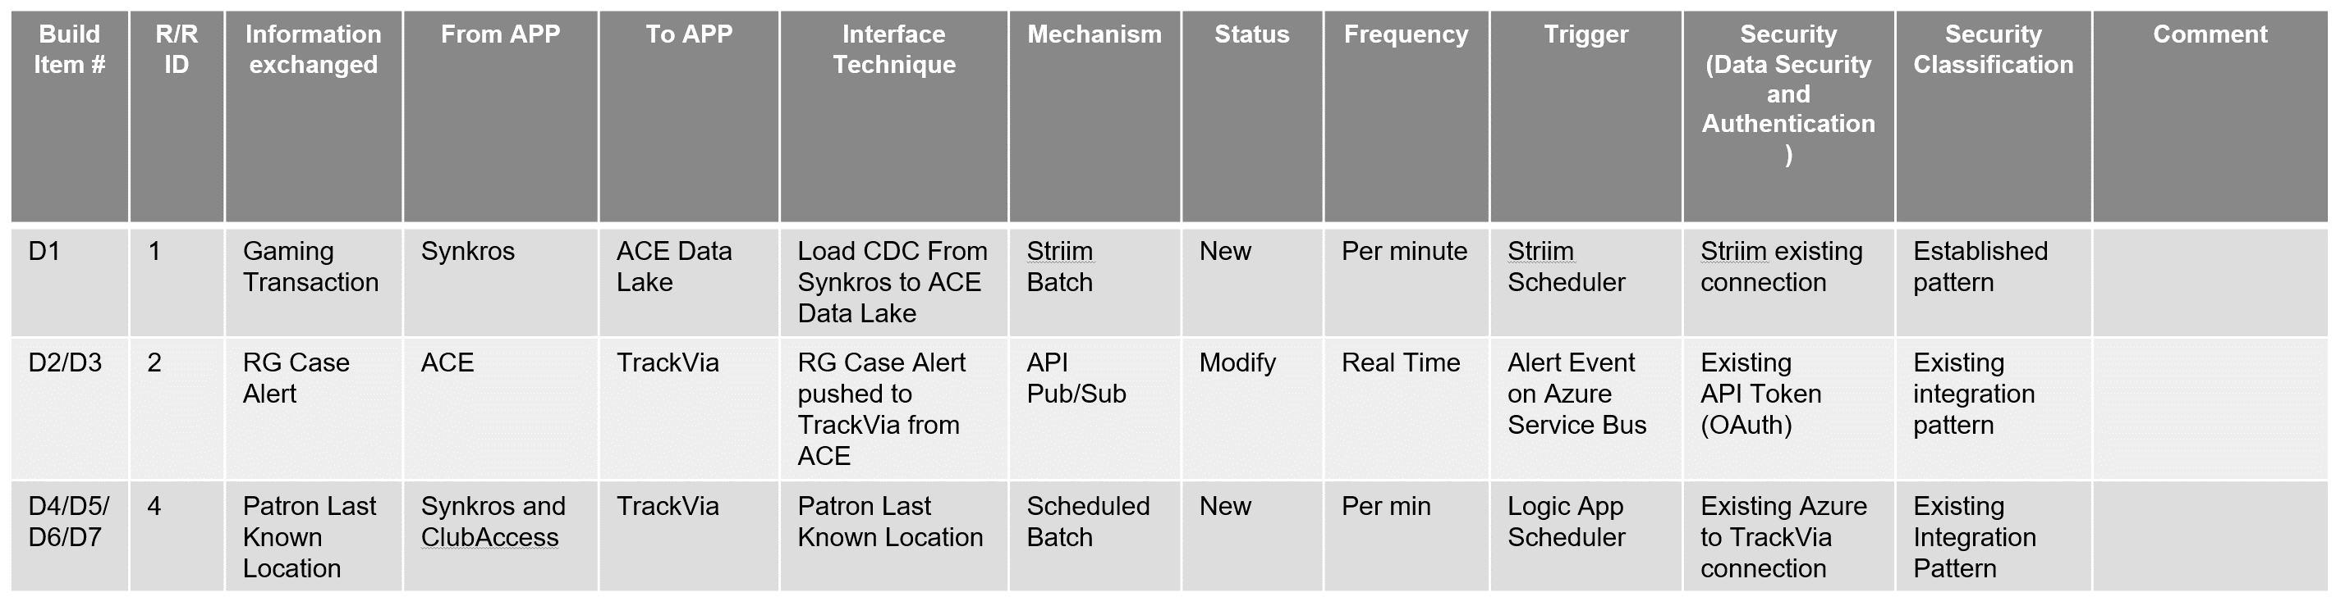

  - Integration
List each impacted interface or service and briefly describe the requirements the solution design expects this to address. Integration to include UML sequence diagrams with cyber security descriptions.
Example
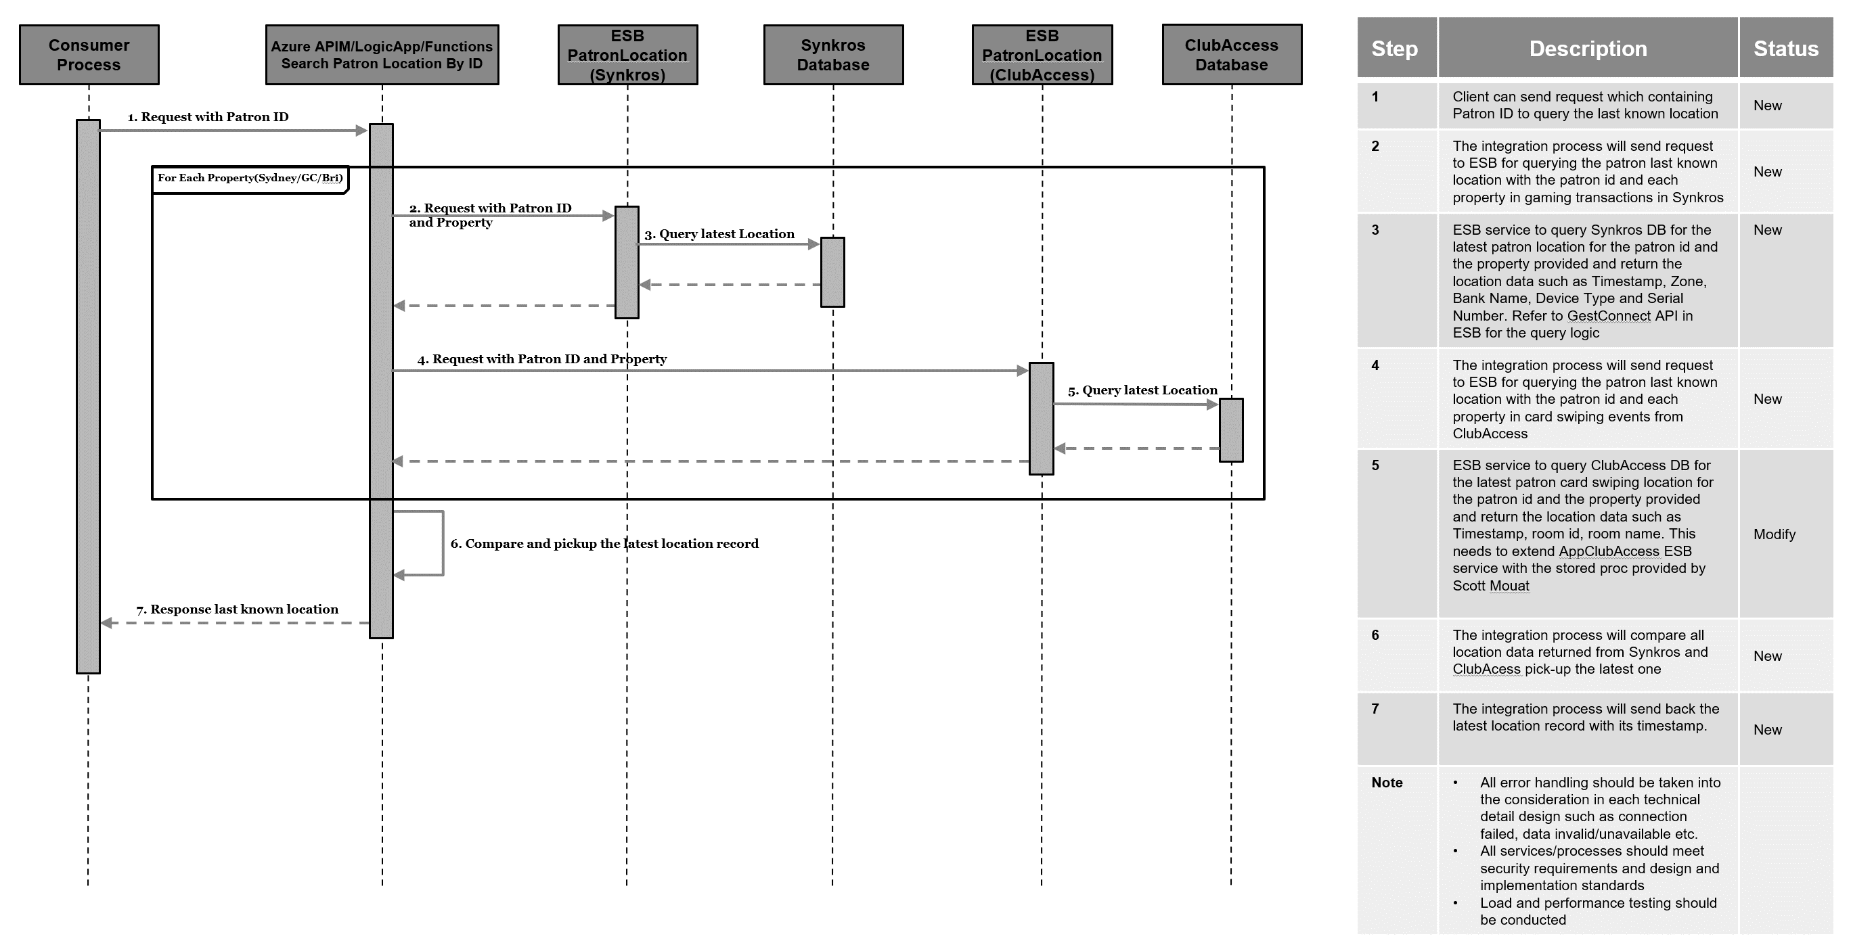

  - Impacted Systems
List each impacted system, application and briefly describe the requirements the solution design expects this system to address.
For each existing system, interface or service describe the changes required to meet the requirements of this business initiative.
Note. Having visibility of end-to-end functionality is key to providing a holistic solution. Depending on the size and nature of the project different techniques can be employed to identify and record these end-to-end system scenarios. The goal is to be able to give the technology domain subject matter experts an understanding of their impacts and therefore related effort.

- Data Architecture
  - High Level Data Architecture Overview
  - Data Model \ Data Flow Diagrams
Example
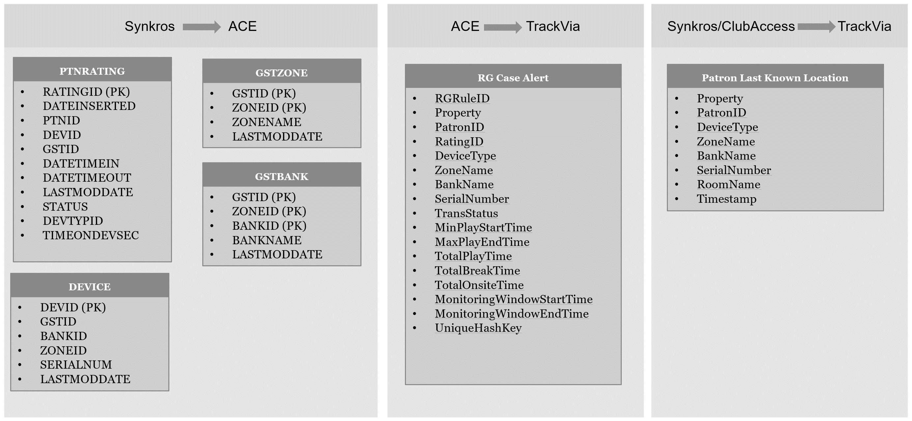
Design Considerations
1. Who / What is moving or changing the data?
- From where to where?
- How is it being moved and how frequently?
- What Data Security is being overlayed to this process?
- What are the components doing with the data in relation to CRUD? Create / Read / Update / Delete
2. Who / What else will have access to the data?
- How is it being accessed?
- What Data Security is being overlayed to that access?
- What is this access doing with the data in relation to CRUD? Create / Read / Update / Delete
3. What Data is in play?
- Ideally Data Entities would be captured (grouping of attributes; e.g. Loyalty Tier, Customer Address, Device Configuration)
- Minimum of Data Subjects should be captured (grouping of entities; e.g. Customer, Loyalty, Gaming)
- What is the level of Data Security Classification relating to the data? Public, Confidential, etc. – Good to know to understand any risk
4. Who / What is currently dependent on the data?
- Will they / it be impacted by these changes?
- How is that impact, if any, being managed?
5. Are any mass changes required in the data as part of the solution?
- Who / What is impacted by the mass changes?
- Will the changes need to be sent anywhere else?
- Is there a data migration solution required?
6. Are there any reporting or analytical requirements, if yes, how are they being delivered?
- Infrastructure
  - High Level Infrastructure Architecture Overview
Describe and show via a diagram, how any new infrastructure will interact within itself and with any existing systems. Where possible, include the physical location of the devices. Comment on the topology of the system, etc. If possible, also illustrate how any data will flow between these systems and how the new infrastructure will interface with existing systems.
Example
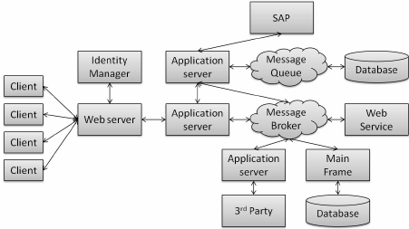
  - Infrastructure
List and server deployments required for the solution, include Site, Server type, Operating system, Type Include ALL environments in the diagram.
Item | Server Description | CPU | Memory | Storage Total GB | O/S Level | Site | Type | Environments
1 | Application Server 1 | 4 | 8 | 100 | Windows 2019 | SYD | Virtual | Prod, UAT, DEV
2 | Application Server 2 | 2 | 12 | 200 | Windows 2019 | SYD | Virtual
3 | Web Server 1 | 4 | 4 | 60 | RHEL 8 | SYD | Virtual
  - Database
Describe what database solution has been chosen. Include any related design features, i.e., shared vs dedicated hardware, shared vs dedicated instance. Also, refer any database specific design decisions made in the design decisions.
Note: SQL CPU licenses are a high-cost item, and if requesting more than 4 CPU’s it will require dedicated SQL licensing which further increases cost.
Database Type | Version | Database Info
MSSQL | 2019 | Application DB

  - Network Services
Describe if the solution will require new network zones or load balancing.
    - Network Cabling
Describe if the solution will require any physical cabling. EG staff Kiosks installed around the property.
    - Data Centre or Edge Switching
Describe if the solution will require any edge switching moves, changes, or additional capacity.
  - Firewall Policy Overview
Provide a high-level network security diagram that provides a view of the security zones and an overview of application traffic flows that impact firewalls. Future detailed design will need to cater for IP’s, ports, vlans, etc.
Example
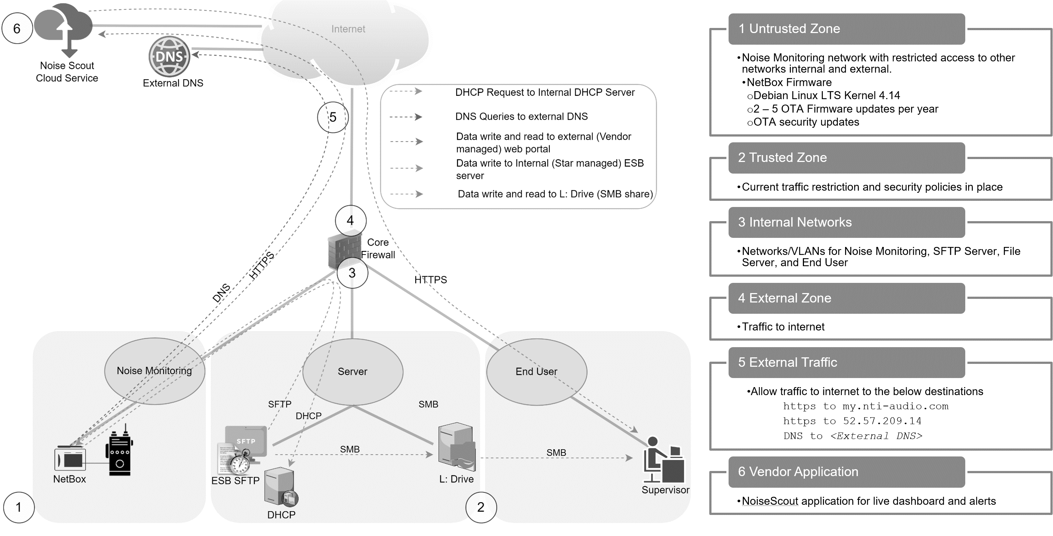
  - Internet Access
Describe if the solution requires internet access. Solution considerations include proxies, firewalls, whitelisting, etc.
  - DNS Configuration
This section describes any DNS entries that will be required for the solution. Internal versus external.
  - Software Components
Describe what infrastructure related software will be installed on the new servers.
  - Infrastructure Uptime & Availability
Define the required uptime and availability and describe how the solution meets this requirement. Describe how high availability is achieved in the solution and how it relates to the required availability of the solution. Identify any single point of failures present in the design and explain why they cannot be remediated (cost etc.). Refer to design patterns if applicable, ex clustering.
- Cyber Resilience
This section provides high-level solution details for the Cyber security aspect of the project. It relates to the corresponding cyber policies and defines how the high-level solution will align.
  - Security Overview
Describe at a high level the overall security of the new solution. Include details such as server placement in security zones, security mechanism (ex. sFTP), encryption, certificates, etc.
  - Data Governance and Classification
Identify and classify the data that will be transacted by the solution.
Data Component | Data Classification | Comments
 | Public, Internal, Confidential, Restricted
  - Cryptographic Keys & Certificate Protection
Describe the mechanisms used to obtain, recover, archive, issue and revoke, control and manage cryptographic keys used to secure information assets.
- How digital certificates will be used and for which connection types.
- TLS Version identified
- Do the certificates require a SAN?

  - Application & Data Security
Secure Communications
- Describe the controls used to protect the integrity and confidentiality of the information assets during transmission.
- How is data transmitted between server – client, Database – Application etc. Is the data encrypted in transit – How – can we use TSEG certificates to view the data

Secure Storage
- Is the data encrypted in storage / at rest – How (Note: Star Netapp Storage volumes are encrypted by default)

  - Identity & Access Management
Describe
- Identity Management
  - Describe is relevant identity lifecycle management provisioning and de-provisioning, role management.
- Authentication
  - Describe the mechanism’s used to authenticate user-to-system or system-to-system (e.g., basic authentication using username/password, multi-factor authentication, Device authentication).
  - How will end users, developers, and support teams will access the servers, platforms (Azure AD, AD, Local accounts, etc). how are privileged accounts managed?
- Authorisation
  - Describe the mechanism’s used to authorise users to system or system-to-system (e.g., role-based authorisation defined within the application, authorisation provided through group membership in external user directories such as corporate Active Directory etc.)

- Describe Service Account requirements
- Reference TSEG Technology Patterns - Identity Access Management v1-0
- Note, detail of users, group names, specifics to be included in detailed design document.

- Supportability & Monitoring
  - Monitoring Overview
Purpose: To ensure solution/designs provide suitable monitoring / observability capabilities to predict/detect/notify of issues to system elements including infrastructure, system interfaces, applications/services, transactional and or user experience metrics.

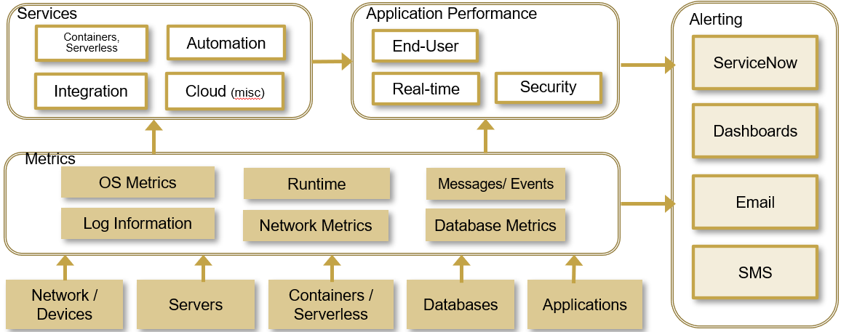
  - Application Monitoring and Alerting

Solution Component | Monitoring Tool | Type Of Monitoring | Environment | Licensing | Solution Outcome
 | Dynatrace | Application / Transactional | (Prod, DEV, SIT etc..) | (Required, Covered) | (Availability, Performance, Security, Business, All-Inclusive
 | Vendor

  - Infrastructure Monitoring and Alerting

Solution Component | Monitoring Tool | Type Of Monitoring | Environment | Licensing | Solution Outcome
Virtual servers | VROps | Overall server health | (Prod, DEV, SIT etc..) | (Required, Covered) | (Availability, Performance, Security, Business, All-Inclusive
Servers | Dynatrace | Availability, Performance, Business | PROD, UAT - Tier 1-2 | Required – Memory based | (Availability, Performance, Security, Business, All-Inclusive
Servers, Internal Services, Websites | SCOM | Availability, Performance, Business | PROD, Physical | Virtual – Datacentre License, Physical CPU Socket | Availability,
Networking | AKiPS | Network Switching Services (SNMP) | Prod, UAT | (Required, Covered) | All-Inclusive
  - Cyber Monitoring, Vulnerability Scanning and Alerting

Solution Component | Monitoring Tool | Type Of Monitoring | Environment | Licensing | Solution Outcome
 | Splunk | Logging | (Prod, DEV, SIT etc..) | (Required, Covered) | Security
 | Tenable | Scanning | Prod, UAT | (Required, Covered) | Security
 | Azure Sentential | SIEM | Prod, UAT | (Required, Covered) | Security
 | Extra Hop | Passive network capture | Prod, UAT | (Required, Covered) | Security
 | Panorama | Palo Alto \ Firewall | Prod, UAT | (Required, Covered) | Security
 | Imperva | Web Firewall | PROD, UAT | (Required, Covered) | Security
 | Crowd Strike | Agents | Prod, UAT | (Required, Covered) | Security

  - Backup & Recovery
This section describes how the solution will meet the Backup & Recovery requirements utilising standard services, Internal DC’s, vendor, cloud services. Include data retention policy requirements, i.e. If required to meet financial compliance of 7 years data retention
Application | Component | Backup, Archiving and Recovery Description
  - Updates & Patching
Describe the to-be state solution RACI covering:
- Schedule updates and patching i.e., Vendor, TSEG O/S, Application
- Application installation and updating, application configuration, application, and OS problem resolution, etc.
- Will the solution implement a new capability that will require upskilling of TSEG teams?

  - Maintenance Windows
Any high-level exceptions to typical maintenance requirements that may affect architecture design. Project team will step through a Transition to Operations process to confirm low level detail.
  - Remote Access
Describe how remote access will be provided to the environments.
- Standard Vendor support access
- B2B VPN
- Remote access via Screenshare

  - Disaster Recovery
Classify the DR capability of the Solutions.
- Describe how DR recovery and testing will be achieved in a full site real disaster.
- Describe how DR recovery and testing will be achieved in a full site disaster simulation.

  - Capacity & Performance (Volumetrics)
Describe any performance related design consideration and solutions. Provide details of how capacity planning will be managed.

  - Scalability
Describe how the solution is scalable. If the solution is not scalable, please include a reference to scalability in the design decisions and explain why the solution is not scalable.

Appendix A: Terms & Abbreviations
Term/Abbreviation | Definition
TSEG | The Star Entertainment Group
CSA | Conceptual Solutions Architecture
SLA | Service Level Agreement
SOA | Service Orientated Architecture
AD | Active Directory
DR | Disaster Recovery
VPN | Virtual Private Network

Appendix B: Implementation Considerations
This section describes any potential considerations that apply to the implementation of the project for example:
- Impacted teams
- Proposed build phases
- Recommendations
- Implementation plans
- Project build roles and responsibilities

